|  |  |
| --- | --- |
|  | **Project Title**    Online Saloon and Spa Application |
|  |
|  |

|  |  |
| --- | --- |
| TEAM | 8 |
| G.Lokesh Reddy (TEAM LEADER) | 2476660 |
| Gaddam Venkatesh | 2476300 |
| Godishala Vishalini | 2476029 |
| Divya Bharathi B | 2475463 |
| Hari Venkatesh | 2477545 |
| SS Balaji | 2477635 |

**Table of Contents**

1. **Introduction**

1.1.Project overview

**2.0 Modules**

2.1 Admin

2.2 User

**3.0 ER Diagram**

**4.0 Database Design**

4.1Table structure

**5. Terms & Conditions**

**1.0 Introduction**

**1.1 Project Overview**

With this application we have developed an advanced online salon & spa booking system that can help the users to book an appointment in their favourite salon or spa. The users can easily access the system by registering themselves on the website. The system will provide information on nearby salons/spas & their services. The users can view the salons' facility, services & hair stylists' reviews, and based on that they can choose the best salon with the beautician or hairstylists suited for them and book an appointment as per their desired time & date. The users can also purchase various beauty-related products online. Admin can view the user details registered and their bookings and accept or reject the booking. The system will also allow the users to drop their feedback as well.

**2.0 Modules**

* 1. **Admin**
* **Register:** Admin can register.
* **Login:** Admin can login in his personal account using id and password.
* **View Bookings:** Admin can view bookings
  1. **User**
* **Register:** User can register itself.
* **Login:** User can login in his personal account using id and password
* **Book:**  User can schedule multiple services with selection of respective ecommerce product & beautician.
* **Consultant:** User can view Consultants List
* **View Appointments:** User can view their booked appointments list.
* **Feedback:** User can give feedback

**3.0 ER Diagram**

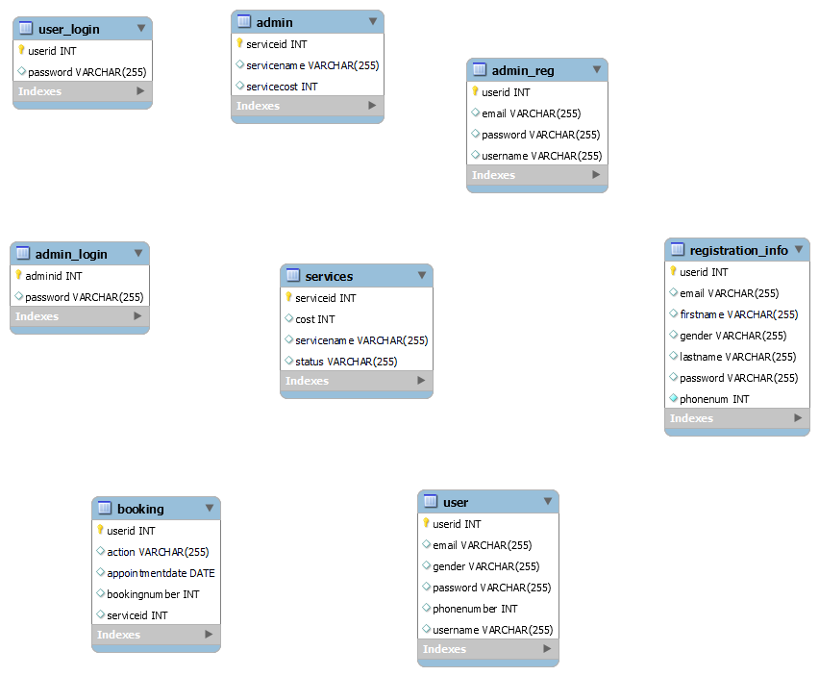

**4.0 Database Design**

4.2 Table Structures

**Admin/ User table:**

|  |  |  |  |
| --- | --- | --- | --- |
| **Column Name** | **Data Type** | **Length** | **Nulls** |
| userid | int |  | - |
| Password | varchar | 255 | - |
| . |  |  |  |
|  |  |  |  |

**Admin/User Registration table:**

|  |  |  |  |
| --- | --- | --- | --- |
| **Column Name** | **Data Type** | **Length** | **Nulls** |
| Userid | int | 30 | - |
| Email id | varchar | 255 | - |
| First name | varchar | 255 | - |
| Last name | varchar | 255 | - |
| Gender | Varchar | 255 | - |
| Phone no | int |  | - |
| Password | varchar | 255 | - |
|  |  |  |  |

**Admin Services table:**

|  |  |  |  |
| --- | --- | --- | --- |
| **Column Name** | **Data Type** | **Length** | **Nulls** |
| Service id | int |  | - |
| Service Name | varchar | 255 | - |
| Service Cost | int |  | - |

**Booking table:**

|  |  |  |  |
| --- | --- | --- | --- |
| **Column Name** | **Data Type** | **Length** | **Nulls** |
| User id | int |  | - |
| Booking Number | int |  | - |
| Appointment | date |  | - |
| Service id | int |  | - |

**Services table:**

|  |  |  |  |
| --- | --- | --- | --- |
| **Column Name** | **Data Type** | **Length** | **Nulls** |
| Service id | int |  | - |
| Service Name | varchar | 255 | - |
| Cost | int |  | - |
| Status | varchar | 255 | - |

**5.0 Terms & Conditions**

1.Clints responsibility

2.Liability for valuables

3.Reservation and right to withdraw

4.Web profile

5.Safety on the website